1. Not sure if there is any use for the Login button on this login page. Please remove the login button. A screenshot of a computer login

   Description automatically generated

Response – <https://prnt.sc/iDQkk2zpLC62>

Connecting on mobile still shows 3 dots as if login button is there.

1. Rename to “TENANCY” , Remove links, Change copyright 2024 name to Tenancy

Response - <https://prnt.sc/ZGOrV_NJcIVp> - Meaning remove the Links Block completely. But keep the space between the social media and news letter.

See below for expected design.

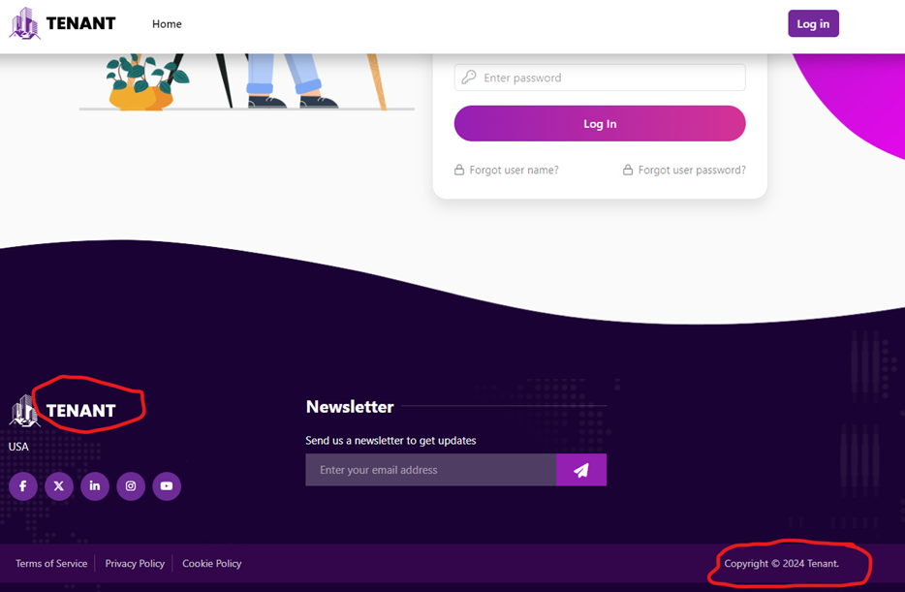

1. Please add user name field to the tenant login side on tenant information page. Same location as it appears on landlord side.

Response - <https://prnt.sc/HnhORekAiSyQ>

Last name should also be a capital letter.

1. 419 page expired error when signed in on multiple devices. I was signed in on my laptop as harryhamlet tenant, and went to my desktop to sign in as harryhamlet and I got a 404 error. Happens on landlord side too
2. Will like to add a filter on search page options for rental status. Active, Expired, All – Default should be active tenants (above advance seach)